**NETFLIX ANALYSIS**

PREPARED BY

**Bhupesh Dhiman**

**03rd March 2024.**

**OVERVIEW**

The streaming industry has revolutionized entertainment consumption, and Netflix stands at the forefront. With millions of subscribers worldwide, Netflix offers a vast library of content across various genres.

The primary goal of this analysis report is to provide actionable insights based on a comprehensive examination of Netflix data. By analyzing different categories of content, we aim to empower Netflix stakeholders with informed decisions for content creation, marketing strategies, and user engagement.

This data analysis report is to provide the findings that Bhupesh Dhiman conducted on doing a descriptive analysis of Netflix’s dataset to uncover valuable insights that can guide content creators, marketers, and decision-makers.

**METHODOLOGY**

The researcher conducted a **descriptive analysis** on a dataset obtained from Kaggle and using Microsoft Excel. Upon completion of the analysis, the researcher explored the data and started generating meaning to the data.

**ANALYSIS**

The Netflix dataset contains unique 5751entries from different categories and genres. The researcher used Pivot Table to carry out the exploratory analysis.

**Result 1:**

Based on the given dataset, the researcher found that United States leads the ranking of country with most Netflix viewership followed by India, UK, Canada and Spain.

Below is a chart representing the data.

**Result 2:**

Upon analyzing the data, the researcher discovered that Jan Suter, closely followed by Marcus Raboy is the director with most movies/shows released on Netflix. Being United States as the country with most viewership, directors from United States dominates the ranking with top 3 directors coming from the same country. The accompanying Pivot Chart serves as a visual representation of these findings.

**Result 3:**

As evidenced in the worksheet, Drama in the international movies is the most viewed Genre. It is evident from the dataset that people prefer to watch drama closely followed by Documentaries. This is likely attributable to the fact that the craze for dramatical movies has been increasing over the time and along with thrillers, people also prefer to watch documentaries for increasing their knowledge and comedies to light up their mood.

Below is the visual representation of the chart with Top 10 Genre:

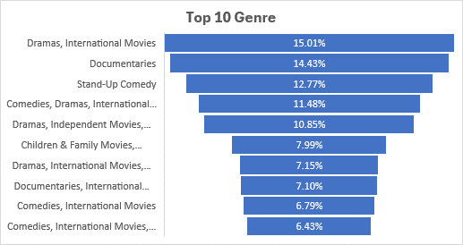

**Result 4:**

Based on the given dataset, the researcher found that over the years, Netflix primarily focused on Movies with 96.71% movies listed in movies category and just 3.29% listed TV shows. Although Netflix makes money out of subscriptions, the reason behind this is that Netflix needed volume in order to compete with the biggest studios on the planet.

The chart below shows the figures.

**Result 5**

It has also been observed that Netflix initially focused on more movies than TV shows year by year in order to attract more customers. It could be supported by the fact that Netflix wants to attract customers by releasing movies on Netflix in order to lure customers for buying their subscriptions and allowing them to spend money on subscriptions and enjoying movies at their homes rather than going out and spending money on cinemas.

After establishing the customers' base, they began focusing on TV shows and movies in order to offer diversity to their customers.

Below is the chart representing the data:

**Conclusion**

Upon completing the analysis, my conclusion is that Netflix is a global recognized brand that is recognized for its high quality content and presence in all counties.

Netflix focused more on Movies in the past in order to attract customers by convincing them to watch their favorite movies at home and also watching as many movies they want in stead of buying movie tickets and going out of their homes. Netflix has revolutionized the industry and with the passage of time, they moved up in the game by creating high quality content and streaming good movies. They offer diversity and understand their customer’s preferences and releases their content accordingly.

Following is the dashboard consisting of the findings from the analysis:

